HYDRAPOWER MACHINES AT HORIZON MARINE

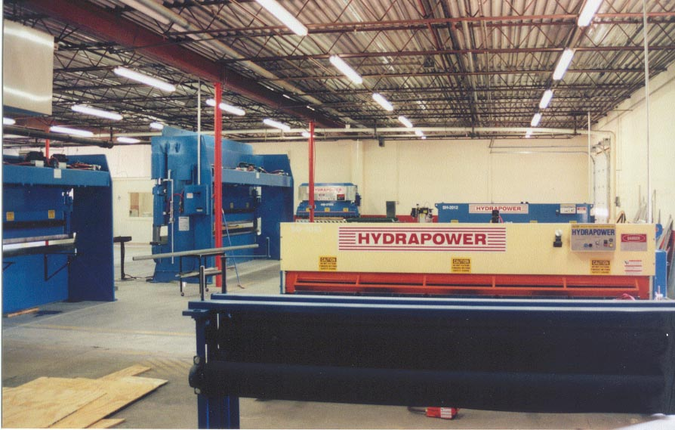

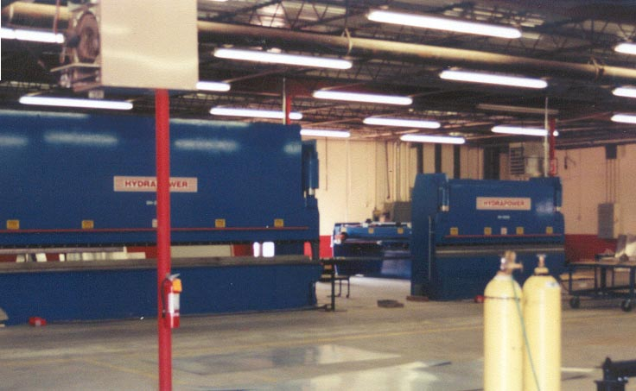
COMPLETE SHOP IS HYDRAPOWER

